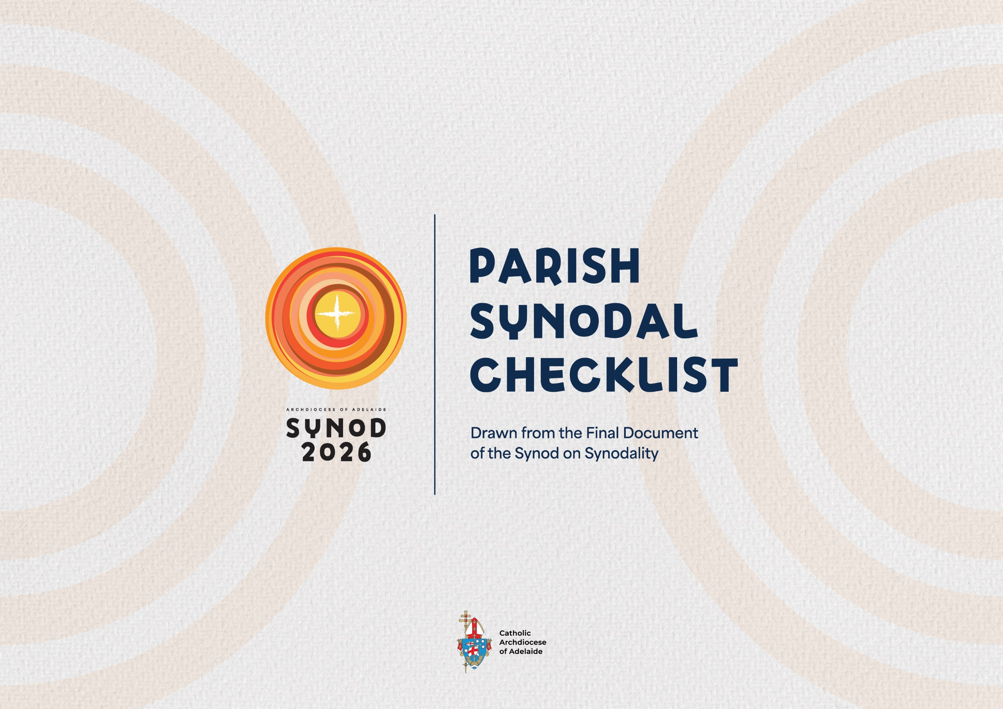

“Synodality is the walking together of Christians with Christ and towards God’s Kingdom, in union with all humanity. Orientated towards mission, synodality involves gathering at all levels of the Church for mutual listening, dialogue, and community discernment. It also involves reaching consensus as an expression of Christ rendering Himself present, He who is alive in the Spirit. Furthermore, it consists in reaching decisions according to differentiated co-responsibilities. Along these lines, we can understand better what it means to say that synodality is a constitutive dimension of the Church (cf. ITC 1). In simple and concise terms, synodality is a path of spiritual renewal and structural reform that enables the Church to be more participatory and missionary so that it can walk with every man and woman, radiating the light of Christ.” (§ 28)

Introduction
This evaluation guide is intended to support the ongoing synodal conversion of the parish and ultimately the Archdiocese. Being a synodal church on mission requires us to reflect on where we are in order to discern where we must go and how to get there. Parishes are integral to the synodal journey of the Archdiocese, so it is important that each parish take time to reflect on their own journey.
This evaluation guide is based on the actions suggested in the Final Document of the second session of Global Synod on Synodality. Part One is a simple evaluation of parish synodal practices. Part Two offers an in-depth evaluation referencing particular actions named in the Final Document.
Support for the growth of synodality in your parish is offered from the Archdiocese of Adelaide. Contact Sarah Moffatt and Peter Bierer for further information.

Sarah Moffatt Peter Bierer
Executive Director Assistant Director
Pastoral Life and Mission Pastoral Life and Mission
smoffatt@adelaide.catholic.org.au pbierer@adelaide.catholic.org.au

PART ONE: Overview Evaluation
The Parish can demonstrate evidence of synodal practices:
Synodal Practice | Met / Not Met | Evidence of the practice | Plan / Strategy to develop the practice
Listening and discernment
practices are regularly incorporated into parish life, especially supporting decision-making.
Decision-making is a shared responsibility across all areas of parish life.
The unique charisms and vocations of parishioners and leaders are encouraged and discerned to support ministry for mission.

The parish provides opportunities for the participation of women, children and families, young people, people with disabilities in leadership, ministry and mission.
Clergy and laity exercise leadership in the parish with Co-responsibility.
Efforts toward Transparency, accountability and evaluation are evident in the parish.
Safeguarding and integrity are prioritised.
Synodal structures (councils, assemblies, etc.) in the parish
Opportunities for Synodal formation for all parishioners is provided in the parish.
Those in positions of leadership and responsibility have regular opportunities to engage in Leadership formation for mission.

PART TWO: In-Depth Evaluation

The Parish can demonstrate evidence of synodal practices: LISTENING AND DISCERNMENT
“The synodal process has renewed the awareness that listening is an essential component of every aspect of the Church’s life.” (§ 78)
As ecclesial discernment entails the contribution of everyone, it is both the condition and a privileged expression of synodality, in which communion, mission and participation are lived. The more everyone is heard, the richer the discernment. Therefore, it is essential that we promote the broadest participation possible in the discernment process, particularly involving those who are at the margins of the Christian community and society. (§ 82)
Checkpoint | Status | Evidence | Plan
Consultation and discernment are regular practices when making decisions in the parish. (§ 9)
Parishioners have opportunities to participate in consultation and discernment. (§ 9)
We make time to listen prayerful to the Word of God as part of our listening processes (§ 83)
The parish engages / has engaged the services of a trained facilitator to guide listening and accompaniment practices in parish life. (§ 78)
The parish seeks to listen to the contributions of other Christian communities and other religious groups in the area. (§ 107)

The Parish can demonstrate evidence of synodal practices: SHARED DECISION-MAKING
“Decision-making processes need ecclesial discernment, which requires listening in a climate of trust that is supported by transparency and accountability. Trust must be mutual: decision-makers need to be able to trust and listen to the People of God. The latter, in turn, needs to be able to trust those in authority.” (§ 80)
“In the synodal Church “the whole community, in the free and rich diversity of its members, is called together to pray, listen, analyse, dialogue, discern and offer advice on taking pastoral decisions” (ITC 68) for mission.” (§ 87)
Checkpoint | Status | Evidence | Plan
Synodal decision-making processes are modelled at by parish leadership and councils and supported in all of parish life. (§94)
The parishes is able to provide evidence of synodal decision-making processes. (§94)
The parish has a communication strategy to ensure transparency and accountability of discernment and decision-making processes and outcomes. (§94)

The Parish can demonstrate evidence of synodal practices: CHARISM, VOCATION AND MINSTRY FOR MISSION
“In the Christian community, all the Baptised are enriched with gifts to share, each according to his or her vocation and way or condition of life. The various ecclesial vocations are many, yet they express the one Baptismal call to holiness and mission.” (§ 57)
Checkpoint | Status | Evidence | Plan
Parishioners are given opportunities to discern their own gifts (charisms) and vocation. (§57)
Parishioners are given opportunities to share their gifts with the parish community. (§57, §66)
The parish provides opportunities and pathways for parishioners to share their gifts in ministry and service in mission to the wider community / world. (§59, §66)
Ministry leaders (paid and volunteer) are publicly recognised and commissioned in their roles for the parish. (§76)
Those exercising ministry in the parish (ordained, laity, volunteers and employees) are regularly evaluated for improvement, planning, and discernment. (§100)
The parish has an online presence (website, social media, etc.) and engages digital media for mission. (§113)
The parish engages with ecclesial movements, associations and communities, including cultural chaplaincies, to strengthen relationships and unity. (§118)
The parish is committed to defending life and human rights, for the proper ordering of society, for the dignity of work, for a fair and supportive economy, and an integral ecology. (§151)

The Parish can demonstrate evidence of synodal practices: INCLUSIVE PARTICIPATION
“Each Baptised person responds to missionary needs in the contexts in which they live and work, according to their dispositions and abilities” (§ 58)
“The way to promote a synodal Church is to foster as great a participation of all the People of God as possible in decision-making processes.” (§ 87)
WOMEN
Checkpoint | Status | Evidence | Plan
Women are in roles of leadership and decision-making. (§60)
Consideration is given to the use of language and images which reflect gender equality, cultural diversity, in parish communications, liturgies, homilies and programs. (§60)
The parish actively seeks to give space to female saints, theologians and mystics, and use language and images that adequately reflects the rich diversity of the local church. (§60)

CHILDREN AND FAMILIES
Checkpoint | Status | Evidence | Plan
Children are appropriately included in consultation, discernment and decision-making processes, especially in matters that directly affect them. (§61)
The voice and contribution of children is valued in the parish. (§61)
The parish collaborates with the local Catholic school(s) to provide opportunities to gather with children and young families, network, participate in formation, and celebrate family life. (§64)

YOUNG PEOPLE
Checkpoint | Status | Evidence | Plan
Young Adults are appropriately included in consultation, discernment and decision-making processes, especially in matters that directly affect them. (§62)
The voice and contribution of young adults is valued in the parish. (§62)
Young Adults are given opportunities to participate in leadership roles in the parish. (§62)
The parish ensures young people are accompanied in faith development and circumstances of life. (§62)

PEOPLE WITH DISABILITIES
Checkpoint | Status | Evidence | Plan
The physical spaces of the parish adequately accommodate for diverse physical abilities/disabilities. (§63)
The parish accommodates for diverse mental and social abilities and special needs. (§63)

The Parish can demonstrate evidence of synodal practices: CO-RESPONSIBILITY – CLERGY AND LAITY
“The lay faithful, both men and women, should be given greater opportunities for participation, also exploring new forms of service and ministry in response to the pastoral needs of our time in a spirit of collaboration and differentiated co-responsibility.” (§ 77)
Checkpoint | Status | Evidence | Plan
The parish priest, additional clergy and lay leaders in the parish work in a co-responsible, collaborative way, sharing tasks, responsibilities and decision-making. (§74)
Lay men and women participate in parish discernment processes and all phases of decision-making processes (drafting, making and confirming decisions). (§77)
The parish employes lay men and/or women in positions of leadership, responsibility and decision-making. (§77)
Laity employed by the parish are adequately compensated and supported with respect and dignity. (§77)

The Parish can demonstrate evidence of synodal practices: TRANSPARENCY, ACCOUNTABILITY AND EVALUATION
“Decision-making does not conclude the discernment process. It must be accompanied and followed by practices of accountability and evaluation undertaken in a spirit of transparency inspired by evangelical criteria” (§ 95)
Checkpoint | Status | Evidence | Plan
Parish Finance Council is effective and functional as a synodal body of the parish. (§102)
The People of God are effectively involved in pastoral and financial planning in the parish (e.g. Parish Pastoral and Finance Councils). (§102)
The Parish produces and makes publicly available an annual finance report. (§102)
The parish produces and makes publicly available an annual account of the carrying out of the Church’s mission. (§102)
We are regularly evaluating the synodal practices and journey of the parish. (§9)
We are regularly evaluating the participation of the Baptised in the life of the parish (§9)
Parish structures and ministries are regularly evaluated. (§100)
Outcomes from evaluations contribute to discernment and planning for mission (pastoral planning). (§100)

The Parish can demonstrate evidence of synodal practices: SAFEGUARDING AND INTEGRITY
“Another area of great importance is the promotion in all ecclesial contexts of a culture of safeguarding, making communities ever safer places for minors and vulnerable persons” (§ 150)
Checkpoint | Status | Evidence | Plan
The parish give consideration to education in safe online practices including formation in discernment of online religious content. (§149)
The parish understands that safeguarding is about our shared commitment as the People of God to safety and protection of the vulnerable. (§150)

The Parish can demonstrate evidence of synodal practices: SYNODAL STRUCTURES IN THE PARISH
“The Baptised participate in decision-making, accountability and evaluation processes through institutional structures, primarily through those already provided for the local Church set out in the existing Code of Canon Law… Each of these bodies plays a role in the discernment needed for the inculturated proclamation of the Gospel, for the community’s mission in its milieu, and for the witness of the Baptised.” (§ 103)
Checkpoint | Status | Evidence | Plan
The parish has appointed someone to support our synodal growth, practices and culture. (§9)
The Parish actively participates in Diocesan Assemblies, Synods, Regional and Deanery Assemblies. (§103, §107)
The Parish regularly hold Parish Assemblies. (§107)
The Parish has a Parish Pastoral Council. (§103)
The Parish has a Parish Finance Council. (§103)
There is a clear and transparent process for members to propose agenda items to the agenda of the Parish Pastoral Council. (§105)
Participatory bodies (councils, assemblies, etc.) have adopted a synodal working style, such as Conversations in the Spirit. (§105)
Members participate in these bodies on the basis of their role and differentiated responsibilities and capacities (charisms, ministries, experiences, competencies, etc.). (§103)
Membership of participatory bodies (councils, assemblies, etc.) account for greater involvement of laity, women, young people and those living on the margins. (§106)
The Parish regularly evaluates the composition of members of Parish Councils to balanced the representation, diversity and skillset (as required) of members. (§106)
Chairpersons of the Parish Pastoral Councils and Parish Priests participate in the regular gatherings with the Archbishop and Diocesan Pastoral Council. (§107)
Clear and consistent communication takes place between the Parish Pastoral Council and Parish Finance Council. (§107)
Parish Pastoral Council members are encouraged to gather with neighbouring PPCs in the region or deanery for networking and formation. (§107)

The Parish can demonstrate evidence of synodal practices: SYNODAL FORMATION
“Formation is needed in order to engage in decision-making processes grounded in ecclesial discernment and which reflect a culture of transparency, accountability, and evaluation. The formation required is not only technical; it also needs to explore theological, biblical and spiritual foundations. All the Baptised need this formation in witness, mission, holiness and service, which emphasises co-responsibility. It takes on particular forms for those in positions of responsibility or at the service of ecclesial discernment.” (80)
Checkpoint | Status | Evidence | Plan
Formation in synodality is incorporated into parish life. (§9)
Parish formation programs and resources should include formation in in ecclesial discernment for decision-making processes. This includes formation in witness, mission, holiness and service, which emphasises co-responsibility. (§80)
Parish formation opportunities include formation in ecclesial discernment focused on mission. (§86)
The parish provides formation opportunities in the vision of Drawn into the Joy of the Gospel, (bearing witness to the joy of the Gospel and growing in the practice of synodality). (§141)
Formation in the parish includes Catholic Social Teaching. (§151)

The Parish can demonstrate evidence of synodal practices: LEADERSHIP FORMATION FOR MISSION
“It is essential to offer formation opportunities that spread and nourish a culture of ecclesial discernment focused on mission in local Churches, starting from small ecclesial communities and parishes. This is particularly necessary amongst those who hold leadership roles.” (§ 86)
Checkpoint | Status | Evidence | Plan
Ministry leaders and coordinators receive formation regarding the use of inclusive language and images in preaching, teaching and catechesis. (§60)
Listening and accompaniment practices are central to the formation of all parish ministry participants and leaders. (§78)
Members of parish councils, commissions, and other advisory and consultative groups should include formation in ecclesial discernment for decision-making. (§80)
Parish leaders receive training in ecclesial discernment practices for decision-making. This includes witness, mission, holiness and service, which emphasises co-responsibility. (§80)
Members of parish councils, commissions, and other advisory and consultative groups should include formation in ecclesial discernment for decision-making for mission. (§86)

